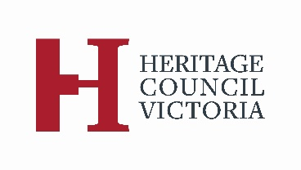

SUBMISSION TO THE
HERITAGE COUNCIL

regulation 7
- Submitter Details
Title
First Name
Surname
Address
Email Address
Telephone

Is this submission on behalf of a company or organisation?
What is its name?
What is your position title?

- Place or Object Details
Place or object name
Address or GPS location

- Details of Executive Director’s Recommendation
Date of recommendation
Recommendation was to *include / *not include (delete if not applicable)

- Purpose of Submission
Note: This submission must relate only to whether or not a place or object is of cultural heritage significance or to the recommended extent of registration or permit policy or permit exemptions.

This submission
- Supports the Executive Director’s recommendation
- Objects to the Executive Director’s recommendation
- Supports the “Extent of Registration” and “Permit Policy/Permit Exemptions” recommended by the Executive Director
- Objects to the “Extent of Registration” and “Permit Policy/Permit Exemptions” recommended by the Executive Director
- Other (please state)

Reasons for submission:

- Hearings
Do you wish to cause a Heritage Council hearing in relation to this matter?
- Yes
- No
Note: If you cause a hearing you may be requested to lodge a detailed submission to support your position.

If a hearing is caused by another party do you wish to participate in the hearing?
- Yes
- No
Note: If a hearing is not requested by another party the Heritage Council may determine the matter on written submissions.

Note: In the event of a hearing, your submission will be provided to other interested parties and your personal details will not be removed. The Heritage Council is also bound by the Freedom of Information Act 1982. You should expect your submission to be freely and wholly available to anyone seeking access to it.

- Submitter Statement
I state that the information I have given on this form is correct to the best of my knowledge.

Name

Signature

Date

Form lodgment details
Please send this form to:

Heritage Council of Victoria
DELWP GPO BOX 527
MELBOURNE VIC 3001

Email: heritage.council@delwp.vic.gov.au

For further information, please contact the Heritage Council Hearings Coordinator on 03 9194 0868

